Suffolk’s Threshold of Need Guidance
2024

Contents

Threshold of Need Guidance

Who is this document for?

Threshold of Need

Family Support

Suffolk Youth Justice Service

Children with a Disability

Children with SEN

Children in Need

Children in Need of Protection

Children in Care

Making a Referral

Assessment of Need

Factors to Consider When Making a Referral

Community and Contextual Safeguarding

Useful Contact Numbers

Suffolk Safeguarding Partnership – Threshold of Need Guidance

This threshold guidance has been compiled by the Suffolk Safeguarding Partnership and partners. It meets the requirements of the Government’s ‘Working Together to Safeguard Children 2023’.

It is designed to help identify when a threshold has been reached, indicating when a child, young person or family might need support and then to identify where best to get this support from.

Children, young people, and their families have different levels of need and these may change over time.

The Signs of Safety and Wellbeing (SOS) Model of intervention has been adopted by Suffolk County Council. It is an evidence based, solution focused model and provides a framework to capture and balance concerns and risks alongside strengths. The Threshold Guidance should be used to inform SOS practice and interventions.

Who is this document for?

- Anyone who is in contact with children and families and who has a concern about a child or young person and wants to know how they should help them.

- All children’s service partners to ensure there is clarity on thresholds and to enable them to be consistent in how they support children who are referred to them.

- All professionals from all agencies working with children and young people have a shared responsibility to keep them safe and provide effective, efficient, and coordinated services to support their health and well-being.

Threshold of Need

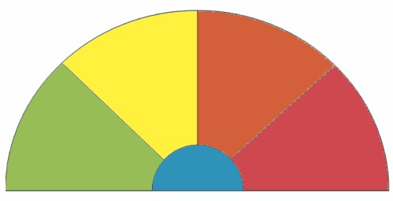
IF UNSURE CONSULT
High Risk Complex or Acute level of additional needs requiring specialist or statutory integrated response or Child Protection
(Section 47)
Level 4

Medium Risk
High or Complex Level of additional needs ranging from Family Support to Child in Need
(Section 17)
Level 3
Low Risk to Vulnerable
Family Support
Multi-agency
Multi-agency Assessment
Level 2
Universal
This supports children and families with Low Level Need
Single Agency Assessment
Level 1

Please refer to the Threshold Matrix on pages 6 of this document for more details on the needs and risks at each level.

Understanding Thresholds

Level 1 - Universal - All children and young people accessing mainstream services with low-level need can be met through a single agency assessment.
Level 2 - Low Risk to Vulnerable - Children with emerging needs or low level CCE (child criminal exploitation) / CE (child exploitation) concerns can be met with the support of a multi-agency assessment/Early Help assessment or for CCE a Diversion Referral to the Suffolk Youth Justice Service.
Level 3 - Medium Risk - Children with multiple or complex needs including medium risk of CCE/CE have to be met by targeted services or by a multi-agency Early Help assessment, or for CCE a Diversion Referral to Suffolk Youth Justice Service or by a Child In Need social work assessment.
Level 4 - High Risk- Children and young people who present with complex needs/risk. Including high level CCE/CE concerns/risk. They will require specialist services and multi-agency statutory response.

Understanding thresholds and how they relate to the support of identified needs is vital to providing a multi-agency intervention that will help children and young people achieve their full potential. The needs of children and young people will change and the communities and environments they live in will also change. We therefore need to ensure that we provide ‘the right intervention and help at the right time’. A smooth transition through the continuum is essential to support their journey from needing, to receiving the help and support they require. It is vital that children, young people, and their families receive appropriate support and services regardless of where they live or how accessible services are.

Children and young people can move from one level to another, and as they do, their needs, as well as support from other services, will either increase or decrease. Movement between levels of services should happen fluidly by ensuring that information is shared appropriately, and that evidence of involvement and interventions are recorded systematically.

The Threshold Matrix can be found on the Suffolk Safeguarding Partnership website at the following link.

Suffolk Threshold Matrix

Family Support

The Early Help Service in Suffolk is now known as Family Support.

Working Together 2023 states that effective Early Help requires local agencies working together to:
- Identify children and families who would benefit from Early Help.
- Undertake an assessment of the need for Early Help which considers the need of all members of the family.
- Ensure good ongoing communication, for example through regular meetings between practitioners who are working with the family.
- Co-ordinate and/or provide support as part of a plan to improve outcomes. This plan will be designed together with the child and family and updated as and when the child and family needs change.
- Engage effectively with families and their family network, making use of family group decision making, such as family group conferences to help meet the needs of the child.
The Early Help Assessment Framework (formerly known as Common Assessment Framework or CAF) is the baseline assessment for any professional to use. The EHA is used by practitioners in a wide range of settings and circumstances. It helps to identify early intervention services which will focus on improving life outcomes for the child or young person.
It provides agencies with the same standard baseline assessment from which more specialist assessments can be developed and enables agencies and families to explore and understand the child/young person’s development needs, the family and environmental factors and the care provided by their parents or carers. It can also be used when a child/young person has additional needs or where identified as being vulnerable.
Many children and young people’s needs are met by universal services or by a single agency. The assessment part of the EHA identifies what help the child or young person and family require, at the earliest opportunity, preventing needs escalating to a point where intervention would be needed in a social work assessment.
It is designed for use when:
- you are worried about how well a child or young person is progressing.
- a child or young person or their parent/carer raises a concern with you.
- the child or young person’s needs are unclear.
- the assessor is seeking to have a conversation that could lead to the identification of how to help the family by providing further information, advice, and guidance without the need for referral to Suffolk County Council's Family Support Team.

Request for a Service from Family Support
Referrals to SCC CYP Family Support Team can be made via an Early Help Assessment (EHA) when the child, young persons or family’s needs are deemed to be moderate to complex and require additional help via a multiagency approach.
For example:
- You/child/young person/family think that the child or young person has unmet needs that cannot be addressed by you and the family.
- You are worried about how well a child or young person is progressing or their needs are unclear.
- The existing support is not sufficient, and families are struggling and need additional help.
- It is likely that the child or young person's needs can only be met by two or more agencies working together.
If at any point during the Early Help Assessment, risk increased and there is concern that the child/young person is suffering significant harm then a referral should be made to Customer First.
More information about Early Help Assessments and Family Support can be found on the
Suffolk County Council Website

Suffolk Youth Justice Service

SYJS is a multi-agency team which includes Probation, Police and Health workers and works collaboratively with a range of partners including Social Care, Family Support and Education. The Suffolk Youth Justice Service (SYJS) works with children and young people who are in, or on the edge of the Youth Justice System together with their parents or carers, and the victims of those offences as well as the wider community. As well as supervising young people sentenced by the criminal courts, SYJS also delivers a Diversion programme offering early intervention and prevention services in partnership with Suffolk Constabulary.

Diversion Programme

SYJS believes in working with young people at risk at the earliest opportunity and seeks to maximise opportunities to divert children and young people from the formal criminal justice system in every appropriate case. The Diversion Programme is a voluntary programme which works with those aged 10-17 who are at risk of offending or anti-social behaviour or are suitable for diversion from formal criminal justice processes. Young
people who are at risk child criminal exploitation (CCE), through gangs or county lines and young people who commit harmful sexual behaviour (HSB) are a priority group for this intervention. An assessment is undertaken, and an individual plan put in place to help the young person desist offending. The Diversion Programme accept referrals, from schools, police and other partner agencies, as well as parents/carers and self-referrals.

Children/Young People with a Disability/Children and Young People with Complex and Critical Needs

Suffolk has a graduated approach to support for Disabled Children and Young People in line with the Suffolk Threshold Matrix.
If the child is deemed to have eligible needs using the threshold matrix, there could be a number of outcomes to help and support both the child and the parent (s). This can range from support from universal services, which are the support services all children may need to access to meet their developmental potential, through to support from a range of agencies following a Section 17 Child in Need Assessment.
All disabled children and young people under the age of 18 are able to have a Section 17 Child in Need assessment. The nature of the assessment will be proportionate to their presenting needs. The MASH will use the threshold matrix to support the process and identify where universal, targeted, specialist services are required.
A Section 17 Child in Need assessment will be completed to inform what level of support is required to meet need, where this is requested or where the MASH considers this to be appropriate, and the family agree.
A Section 17 Child in Need assessment identifies if there is a need for Social Care support, or whether other services are appropriate to meet identified needs.
The Disabled Children and Young People’s Team are a specialized team offering Social Work support to children and young people from age 0-17. The team has a threshold criteria which will be referenced by the MASH and other social work teams internally, to agree when it is appropriate for a child or young person to be allocated to the team. A child or young person with a disability and a presenting social care need, who does not meet the criteria for the Disabled Children and Young Person’s Team, can be supported through the wider children’s social care service.
The DCYP Threshold Eligibility Criteria can be found at the following page on the Suffolk Safeguarding Partnership’s website.
DCYP Threshold Eligibility Criteria

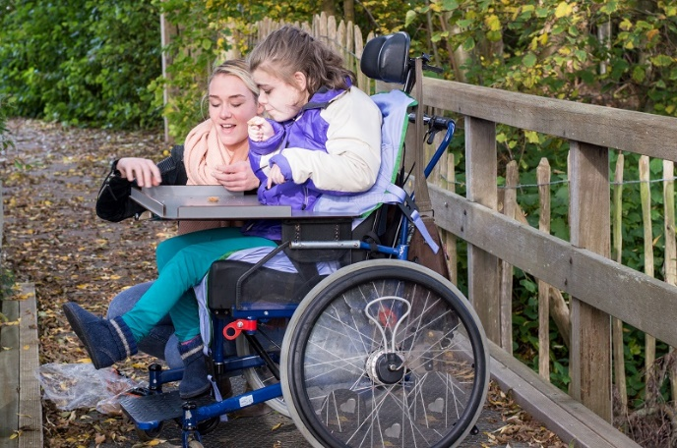

Children with Special Educational Needs (SEN)

What is SEN?
A ‘Special Educational Need (or SEN)’ means help that is in addition to, or different from the support generally given to all children of the same age. Teachers make adjustments so that they can meet the wide range of needs for all the children in any given class and this is known as ‘differentiation’.
A school will only recognise a child has a Special Educational Need (or SEN) if they need further adjustments or support on top of ‘differentiation’. A child does not need a medical diagnosis to be recognised as having SEN, but a disability which creates barriers to education may also be the trigger for additional support.
SEN is not always about a child's academic attainment. There are four broad areas of need and a full description of each can be found in the SEND Code of Practice 2015:
- communication and interaction.
- cognition and learning.
- social, emotional and mental health difficulties.
- sensory and/or physical needs.
How are children with SEN supported?
Schools should identify pupils who may be having difficulty and decide whether SEN support is appropriate. Deciding whether to put in place SEN support starts with the desired outcomes, the expected progress and the views and wishes of the child and their parents/carers.
When a school puts in place support for SEN this is known as SEN Support. Mainstream schools:
- use their best endeavours to make sure that a child with SEN gets the support they need – this means doing everything they can to identify and meet children and young people’s SEN.
- ensure that children with SEN engage in the activities of the school alongside pupils who do not have SEN.
- designate a teacher to be responsible for co-ordinating SEN provision – the SEN co-ordinator (SENCO).
- inform parents when they are making special educational provision for a child.
- prepare a SEN information report.
What if a child still makes less than expected progress?
If a child is not making the expected progress despite the support in place, the setting might consider involving a specialist educational service or a therapist/mental health specialist. The full range of services available to children and young people with SEND are on the Suffolk Local Offer. A small number of children with SEN will have their needs and provision set out in an Education, Health and Care plan and Family Support practitioners will be required to provide advice for these.
Children in Need

The Children Act (1989) Section 17, states that a child shall be considered In Need if:
- They are unlikely to achieve, maintain or have the opportunity of achieving or maintaining a reasonable standard of health or development without the provision of services by a local authority.
- Their health and development are likely to be significantly impaired, or further impaired, without the provisions of such services and/or.
- They are disabled.

The social work assessment should be a quality effective assessment leading to sustainable purposeful plans and interventions, which are developed through meaningful relationships with children, their families and those involved with them. Social work assessments are undertaken in a timely manner reflecting the needs of the individual child. These may be needs that have to be resolved urgently or may include support for vulnerable children and young people who are in private fostering arrangements, children with a disability and children with complex needs. Children or young people, who have special educational needs, who are vulnerable young carers or who have committed a crime may also require an assessment. If the assessment determines the child or children are Children in Need, a multi-agency plan will be developed with the family indicating which agencies will provide services for the child and family. The plan will follow the Signs of Safety model to address the worries, identify the strengths and will have achievable and measurable goals which will be reviewed with the family.

Children in Need of Protection

The Children Act (1989), Section 47 states that where a Local Authority:
a) Is informed that a child who lives or is found in their area.
i. Is subject of an emergency protection order.
or
ii. Is in police custody.

b) Has reasonable cause to suspect that a child who lives or is found in their area is suffering, or likely to suffer, significant harm.

The authority shall make such enquiries as they consider necessary to enable them to decide whether they should take action to safeguard or promote the child’s welfare.

Evidence shows that a single traumatic event can cause significant harm to a child or young person but more often it is a buildup of events, both severe and long-term such as neglect, which interrupt, change or damage the child’s physical and psychological development. It may also include serious events such as forced marriage, female genital mutilation, serious self-harm, exploitation, grooming.

Where there is an immediate need to protect a child because there is reasonable cause to suspect that the child or young person is at risk then a contact must be made with Children’s Social Care and the Police immediately.

Child protection concerns include where there is reason to believe that a child or young person is being:
- Subjected to physical abuse.
- Subjected to emotional abuse.
- Subjected to sexual abuse.
- Subjected to or witnessing domestic abuse.
- Subjected to neglect which has impacted on the physical and emotional wellbeing of the child or young person.

Where there are child protection concerns a strategy discussion meeting involving the Local Authority, Police, Health and if needed, other agencies, must take place to decide whether the threshold for a Section 47 enquiry is reached.

If the threshold is met for a Section 47 enquiry, the strategy threshold discussion will determine whether the enquiry is to be taken as a single agency (Police or Social Care) or jointly with other agencies. The enquiry is undertaken to find out what is happening to the child and to consider whether protective action is required, including the need for legal action.

Children in Care

“A child is looked after by a Local Authority if she/he is in their care by reason of a Care Order (Section 31 of the Children Act 1989) or is being provided with accommodation under Section 20 of the 1989 Act for more than 24 hours with the agreement of the parents or of the child if s/he is aged 16 or over.”
Section 20 requires the Local Authority to provide accommodation for a child who requires accommodation where:
- There is no person who has parental responsibility for the child.
- The child is lost or abandoned.
- The person who has been caring for him/her is prevented (whether or not permanently and for whatever reason) from providing him with suitable accommodation or care.
- He/she is over 16 and his/her Local Authority considers his/her welfare is likely to be seriously prejudiced without accommodation.

How will the Local Authority decide whether to accommodate a child under Section 20?
- Is the person a child?
- Is the child a Child in Need?
- Is the child within the Local Authority's area?
- Does it appear to the Local Authority that the child requires accommodation?
- Is the need the result of:
  - there being no person with parental responsibility for the child, for example, where parents are deceased.
  - the child having been lost or abandoned or
  - the person who has been caring for him being prevented from providing him with suitable accommodation or care.
- What are the child's wishes and feelings regarding provision of accommodation for them?
- What considerations, in the light of the child's age and understanding, should be given to those wishes and feelings?
- Does anyone who has parental responsibility for the child who is willing to provide accommodation object to the local authority's intervention?
- If there is an objection by someone with parental responsibility, is there agreement from an individual who has a child arrangements order setting out where the child should live to the local authority's intervention?
Who can provide a Care Order?
Under Section 31 of the Children Act 1989 the Local Authority or any authorised person can apply to the Court for a child or young person to become the subject of a Care Order.
Authorised person means:
- The NSPCC and any of its Officers.
- Any person authorised by order of the Secretary of State to begin proceedings under this section and any Officer of a body which is so authorised; Care Orders can only be made by the Court.

What do the Courts consider before making a Care Order?
The Court must be satisfied:
- That the child concerned is suffering or is likely to suffer significant harm
AND
- The harm or likelihood of harm is attributable to the care given to the child or likely to be given to him if the order were not made, not being what it is reasonable to expect a parent to give or the child being beyond parental control.

Making a Referral

Referral
If the child is in immediate danger, please call 999 and contact the Police.

If you have an immediate safeguarding concern, you should contact Customer First on 0808 800 4005 (24 hours). If you want to make a safeguarding referral you will need to use the relevant Suffolk County Council Portal. The first time you complete a form you will be asked to create a Portal account. Suffolk Safeguarding Partnership Make a Referral
Cases open to Social Care or Family Support
In Family Support cases a discussion with the Practice lead or Family Support Manager of the relevant Family Support Team needs to take place. If a child and family have an allocated Social Worker, it is important to contact them in the first instance with any concerns.

Diversion Programme
SYJS accept referrals from:
- Children and Young People's Services
- Educational establishments (schools, PRUs etc.)
- The police
- Parents / Carers
All referrals are then assessed to see if they meet the criteria for further intervention work with the youth justice service.
Please read the referral form guidance (Word, 85KB) before completing the referral form below.
- Online Referral Form (Word, 273KB)
- Online Consent Form (Word, 180KB)
Email your completed the form and consent to your local youth justice team.

Download a Referral form (Word, 282KB). You can print it out and complete by hand.
Seeking Advice
If you are worried about a child, talk to your safeguarding lead within your organisation to discuss your concerns at the earliest opportunity.

You can seek advice from The MASH Professional Consultation line: 0345 6061499 or use the webchat facility on the Safeguarding Partnership website. The MASH Professional Consultation line and the webchat are there for you to discuss the most appropriate and effective way of providing or obtaining help and support for a child (or adult) you feel is at risk of abuse. This will include advice and guidance about making a referral where necessary, including how to involve parents.

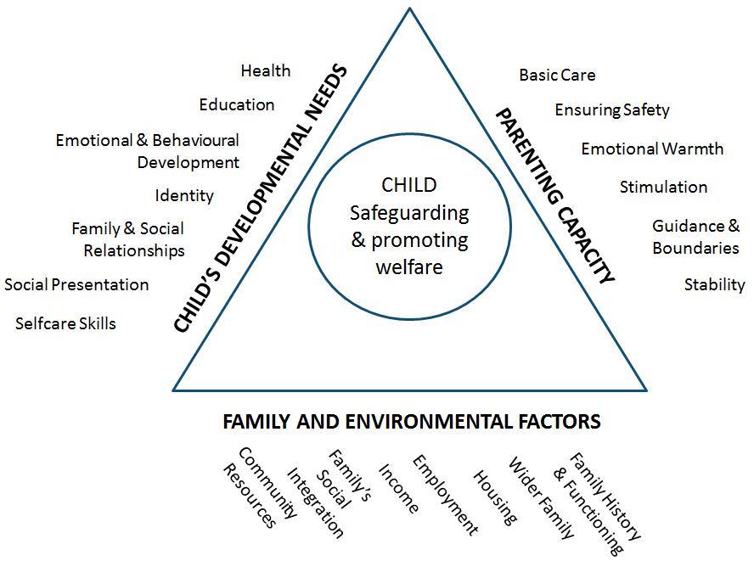
Use the Assessment of Need triangle to support the SOS framework and practice.

Factors to Consider When Making a Referral

- What support or interventions can your agency/organisation offer? Could this meet the needs of the child/young person and their family?
- What is life like for this child/young person and their family?
- What are the child or young person’s wishes and feelings?
- What are the child/young person and family’s strengths and protective factors? Can they help the situation?
- A child’s/young person’s behaviour, health or disability must be understood in the context of the parenting they are experiencing.
- What support or intervention has been offered previously? Did this make a difference?
- Consideration of historical information.
- What are the worries for this child or children?
- Are you clear about the signs and symptoms of neglect?
- Are you clear about the risk factors?
- Have you given consideration to the child’s development?
- Have you considered family and environmental factors and community and contextual factors?
- Have you considered the capacity of parents?

Community and Contextual Safeguarding

Community and Contextual risk factors have been added to the Suffolk Threshold Matrix to reflect that risk has moved beyond home and families out to the communities that children and young people live in and therefore poses new and different risks and vulnerabilities. It is important that children’s workers engage with individuals and sectors who do have influence over/within extra-familial contexts, and recognise that assessment of, and intervention with, these spaces are a critical part of safeguarding practices.
Contextual Safeguarding is an approach to safeguarding that has been developed by the University of Bedfordshire to inform policy and practice approaches to safeguarding adolescents. Contextual Safeguarding is an approach to understanding, and responding to, young people’s experiences of significant harm beyond their families. It recognises that the different relationships that young people form in their neighbourhoods, schools and online can feature violence and abuse. Parents and carers have little influence over these contexts, and young people’s experiences of extra-familial abuse can undermine parent-child relationships.

Useful Contact Numbers

Customer First 0808 800 4005
MASH Professional Helpline 0345 606 1499
Suffolk Police 101 or 01473 613500
NSPCC National Helpline 0808 800 5000
Suffolk Youth Justice Service 01473 260110

Resources on neglect, abuse and risk can be found on the Suffolk Safeguarding Partnership website at the link below.

Suffolk Safeguarding Partnership

Suffolk Safeguarding Partnership
Endeavour House
8 Russell Road
Ipswich
Suffolk
IP1 2BX

Email: enquiries@suffolksp.org.uk

www.suffolksp.org.uk

Policy Version History

Version | Date | Review Date | Author | Endorsed by PP/LIG Group
1 | October 2017 | October 2020 | All Agency Document. | October 2020
2 | Updated with Youth Justice addition May 2020 | May 2023 | All Agency Document. | For Information.
3 | August 2020. | August 2023 | All Agency Document. | October 2020.
4 | January 2022 – minor changes updated to reflect the revised Threshold Matrix. | January 2025 | All Agency Document. | February 2022
5 | January 2024 – links updated, change to EHA from CAF, Family Support from Early Help and addition of DCYP Eligibility and Access to assessment and support and Threshold Criteria | January 2025 | All Agency Document | N/A

